Notes about the papers:

**SPE 5579: The Difficulty of Assessing Uncertainty**

Summary: we have not learned to deal with uncertainty successfully, people are using old methods to solve new problems and it’s not working.

Problems:

* Since people don’t know how to assess uncertainty, they tend to understate it and therefore overestimate decisions (overconfidence)
* Our predictions are often very optimistic

Approach:

* The author uses the SPE-AIME experiment, where participants were tested w 10 questions, where each answer had to be a range dependent on their uncertainty of the answer. There were also “how many beans do you think are in this jar” tests

Solution:

* People are overconfident, so their uncertainty ranges were too narrow, decreasing the chance of their ranges containing the true answer. A solution would be to widen the ranges.
* to plot their ranges to graphically determine their 90% range or whatever percent range is asked for.
* keep records of your own probability statements and compared them to actual outcomes once the outcomes are known

Conclusion:

* people are overconfident, this can have negative impacts on company or person
* Learning how to assess uncertainty better can lead to more accurate cost estimates and return on investments for companies.

Limitation:

* paper tested over issues of the past, assessing uncertainty is for the future, which is much more difficult to do.

**SPE 22025: How to Evaluate Hard-to-evaluate Reserves**

Summary: Authors wrote this to attempt to propose better ways to evaluate difficult to estimate reserves like coal-bed methane, horizontal drilling in fractured reservoirs, etc.

Problem:

* deterministic method exists already, but it doesn’t yield accurate reserve estimates for those harder to estimate situations

Approach:

* case studies in San Juan basin and Austin Chalk. Authors find that adding probability in terms of proven, probable, and possible reserve categories helps to express uncertainty more consistently.
* The case studies focused mainly on providing probabilistic estimates to PUDs, proved, undeveloped reserves.

Conclusions:

* for properties where there is available production history and decline, the deterministic approach is preferred, because there is less initial uncertainty.
* For more difficult to analyze properties, where there is high variation involved, or where there are proven, undeveloped reserves, as is the example of the paper, it is better to apply the probabilistic approach, because it will use the volumetric and analytical approach to estimate reserves until production history is accumulated, then it can adjust estimates based on performance.
* Probabilistic definitions allow probable and possible estimates
* Proven category offers a solid, defendable, conservative estimate
* Adoption of prob reserve definitions for use in the US has hurdles to overcome
* A consensus that reasonable certainty is 75% confidence level (b/w proven and probable) would link them and eliminate confusion.

Limitations:

* Every play is different; some have more variability than others
* Estimator will never truly be 100% of the reserves available until the project has finished producing.

**SPE 25830: A Consistent Probabilistic Definition of Reserves**

Summary: uncertainty is common in PETE, but we have the central limit theorem (when we multiply properties together, we approach lognormal distribution. Adding proved reserves is mathematically illegal.

Problem: probabilistic measures should be added to reserve estimations. Another known issue with probabilistic estimates is that people tend to make their P10, P50, and P90 ranges too narrow, and in the case of the oil and gas industry, estimates that are far off from reality can cost a company millions of dollars.

Approach: Capen explains previous methods of estimating reserves such as the Monte Carlo approach to be incorrect, and suggests a possible solution for better approximation of reserves: using log normal, since the log normal involves multiplication through the use of the central limit theorem, and improves consistency, which will in turn lead to a more reasonable approach of estimating reserves.

Conclusion: through the use a log normal approach for reserve estimation, as long as a full estimation distribution is plotted on the log normal scale, it doesn’t matter what your personal interpretation of “proved” reserves is, as long as you pick a point on the distribution. Also, proved reserves should not be added together, bc it yields incorrect results. We know that reserves are probabilistic in nature.

Limitation: no single well or field has the same characteristics, so its hard to know which ranges of P10,50, and 90 are appropriate

**Additional Notes:**

* Multiplying variables leads to lognormal distribution
* Productive area, net pay, recovery are usually log-normal
* Author suggests to avoid Monte Carlo simulation due to low input range
* Provide entire distribution so your definition of “reasonable certainty” does not matter.

**SPE 107435: Evaluating Resource Plays with Statistical Models**

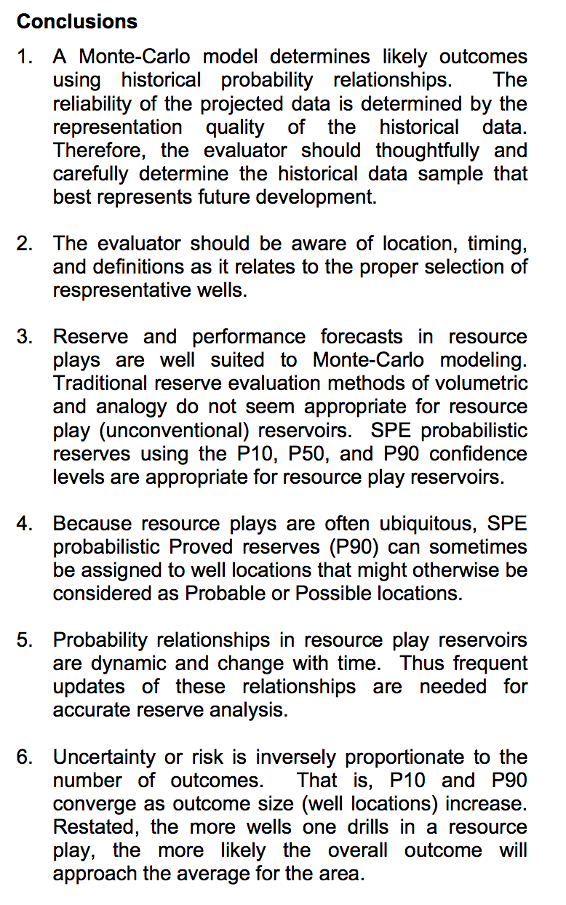

**SPE: 114160: The Evaluation, Classification, and Reporting of Unconventional Resources**

Summary: author focuses on definitions of classification in PRMS and provides a list of questions to help evaluator follow a path for evaluating and reporting unconventional resources, since the steps to evaluate those are diff than for conventional resources.

**SPE: 124938: Managing your Business using integrated PRMS and SEC Standards**

Summary: SEC mandates reporting of proved reserves but disclosure of probable and possible is now optional. It is now possible for companies to manage their business based on PRMS and SEC within a single integrated assessment system.

Here, the author shows the PRMS method and PRMS major principles and explains them, then goes on to give background on SEC reserve disclosures.

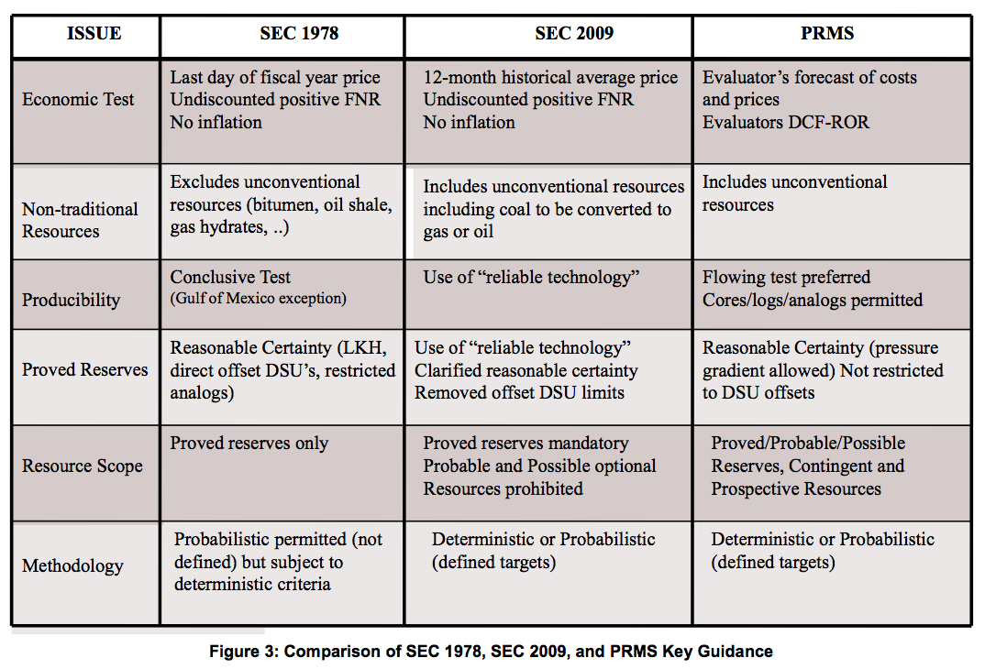

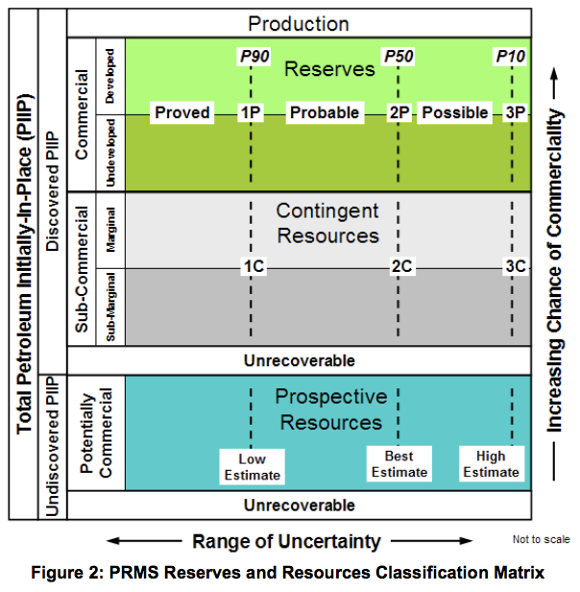

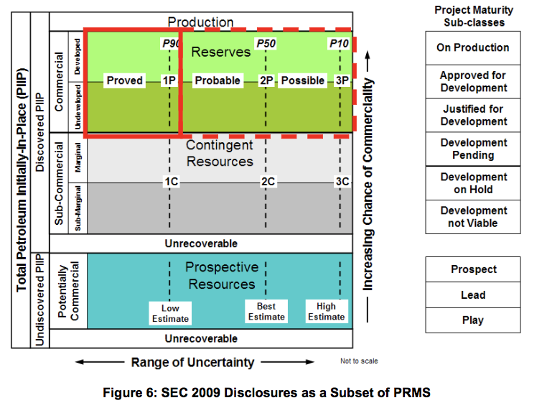  
Conclusions: there’s a very close alignment of SEC 2009 reserve disclosure rules and PRMS reserves assessment guidelines. Bc of this alignment, companies can now refine their internal assessment processes. Companies can focus on efficiencies in managing their business based on PRMS standards but accommodate SEC disclosures within a single comprehensive, integrated assessment system.

**SPE 0206 013 TWA: Some Challenges for Monte Carlo Simulation**

**Problem:** Monte Carlo simulation in the oil and gas industry lacks imagination, and managers are not asking the right questions when making investment decisions.

**Approach:** focus on 3 different types of production forecasts and how to approach them probabilistically. Approaches are: using decline curves for each well and building up field production as new wells come online (implementing drilling and completion schedule with it)

using a pattern forecast for a field (like I did in internship) modeling the shape of the forecast curve as having a ramp up/plateau/decline. This is developed by estimating how long it will take to drill the wells necessary to reach peak rate and how much of the EUR reserves would be produced while on peak rate.

Third approach: reservoir-simulator-generated forecast: although simulators generally generate deterministic prod forecasts, people now use experimental design methods to create multiple runs of the simulators, thereby generating a spectrum of realizations for the prod forecast. He says anyone building production forecasts should account for the possibility of delays.

**Solution/Conclusion:** He then talks about urging young engineers to ask the right, smart questions to managers so that they make better investment decisions. Questions like “what is the chance of finishing the drilling and completion before 15 March? Then he talks about cost estimates and cost/benefit analysis and how to arrange it in terms of uncertainty.

**SPE 63201: Valuing and Comparing Oil and Gas Opportunities: A Comparison of Decision Tree and Simulation Methodologies (searchable)**

**Problem:** Mudford compares decision trees with simulations methodologies both in economic valuation and decision analysis. He tries to prove how it is better to use a simulation since it takes risk into account.

**Method:** talks about gulf of mexico project from exploration through development and compare the results of the comparison of both methods.

**Solution/Conclusion:** In decision trees, EMV is the value of opportunity, but the impact of uncertainties on the EMV is often not assessed. In contrast, with the simulation approach, the NPV distribution is calculated with risk. For the GoM project, a relatively complicated decision tree model is needed so that the EMV is close to the NPV. However, even when the EMV and mean NPV are close, the additional information about the NPV distribution that is part of the simulation output enables risk to be an explicit part of the decision-making process. Although decision tree methods can be extended to include an assessment of risk, since the form of the NPV distribution is not known when using decision trees, a true assessment of project risk is not available. Some conclusions made by the author are that the degree of difference between the NPV determined by the decision tree method or the simulation method will always vary, depending on the complexity of the project. Additionally, using stochastic models leads to better use of sensitivity analysis as well as uncertainty analysis when making decisions in a project.

**SPE 146530: Demonstrating Reasonable Certainty Under Principles-Based Oil and Gas Reserves Regulations (searchable)**

The paper talks about how in deterministic approaches, “reasonable certainty” means “high degree of confidence, and in probabilistic approaches, it means 90% or more confidence that the quantities can be recovered. It goes on to explain how different versions of the SEC have updated the definition of “reasonable certainty” over the years to include both deterministic and probabilistic approaches.

It also talks about using this “reasonable certainty” term has led to a switch from rules-based standards to more principles-based standards. The paper says that rules-based systems have to be constantly updated to fit changing circumstances so that the intended principles are satisfied. The principles-based system reduces the need for continuous updating and can give the evaluator flexibility; it can get rid of “loop-hole” and “checklist” style. This gives the evaluator more responsibility in reaching the desired outcome.

The rules-based system is based on input while the principles based system is based on output. The output would be the “high degree of confidence” that is more likely to increase or stay the same as more engineering and economic data is made available than it is to decrease. The direction of the reserves evaluator is no longer “do it right” but “get it right.” The principles-based approach removes some of the rules required for reporting and give more flexibility to the evaluator, but it is beneficial for someone who is very clear on what their outcome is. For someone who is not very clear on what the outcome of their reserve evaluation is, the rules-based approach is more beneficial.

**SPE 63202: Adapting Probabilistic Methods to Conform to Regulatory Guidelines (searchable)**

**Problem:** probabilistic methods have introduced inconsistent interpretations of how to apply these methods while complying with reserve certification guidelines.

**Objective:** present and discuss some pitfalls commonly encountered in the application of probabilistic methods to evaluate reserves and how to approach these pitfalls. The conflicting reserve interpretations have to do with the current SPE reserve definitions when expressed in terms of probabilities.

They discuss in the paper why defining proved reserves as P90 of any distribution is not always appropriate. The definitions also do not specify whether the evaluator should apply the P90 test at field level or total portfolio level. In this paper they define proved, probable, and possible reserves. Says the SEC does not recognize probable and possible reserves, only proved.

Then they define probabilistic analysis and the risks and benefits of using it. Then address some significant shortcomings in the current reserves definitions. Probabilistic methods provide flexible modeling techniques to evaluate variable interactions and outcome options, which makes this method easy to abuse. “Consistent with the accepted practice that the summation of proved, probable and possible deterministic reserves is not appropriate without risk adjusting each reserve category first, reserve distributions should not be aggregated unless they have been adjusted for their “dry hole” factor.”

**Conclusions**

In this paper, we have discussed how the reserve definitions may affect the implementation of probabilistic methods. The following conclusions can be made from the preceding discussions:

1. Probabilistic methods should not be used as a tool to boost reserve reporting. Probabilistic methods are most useful for the prioritization of the company’s portfolio and the allocation of capital and manpower resources.
2. The evaluation of hydrocarbon resources and reserves may have different objectives and parameters for different audiences. The SEC set those parameters for proved reserve-reporting purposes through their regulations and guidelines.
3. One should keep in mind that the reserve categories have meaning only within the context of their definitions. Therefore, even when the evaluator expects upside recoverable hydrocarbon volumes, those volumes can not be reported if they fall outside the definitions. This ensures consistent reserve reporting among companies.
4. SEC regulations and SPE/WPC reserve definitions may prevent certain variables from being expressed in distribution form during the probabilistic analysis.
5. Satisfying the P-90, P-50 and P-10 from a hydrocarbon resource distribution is not enough to book reserves.
6. The SPE/WPC reserve definitions do not provide guidelines to the appropriate level to which the P-90, P-50 and P-10 are applicable. Also, these definitions do not provide guidelines for the aggregation of prospects. Therefore, extreme caution should be exercised when reporting aggregated volumes as reserves.

**SPE 167242: Evaluation of Time-Rate Performance of Shale Wells using the Transient Hyperbolic Relation (searchable)**

Purpose: demonstrate the “Transient Hyperbolic” nature of the flow behavior from a multi-fractured horizontal well in a shale gas/liquids-rich shale play.

The technical contributions of this work are:

Development of the "Transient Hyperbolic" time-rate relation — this relation includes an early AND a late-time  hyperbolic behavior, as well as a logistic transition function.

Application of the “Transient Hyperbolic” time-rate relation to modeling completion heterogeneity in a MFHW by a  superposition of divisions that have differing durations of linear flow.

Application of the "Transient Hyperbolic" time-rate relation to several field cases — specifically: tight gas, shale  gas, and "liquids-rich" shale cases.

The approach of this paper is to investigate a modification of the Arps hyperbolic model, as an attempt to reconcile the limitations of the original time-rate relation with the long duration transient flow periods observed in the shale gas/liquids-rich shale wells.

This paper introduced the Transient Hyperbolic model as a method of forecasting production in tight gas and unconventional reservoirs. The b factor is meant to represent different points in the reservoir that are either infinite-acting or not, and the time for the transition to occur is proportional to the time at which the transition begins. Fitting time rate data “in a vacuum” is a difficult exercise and may lead to over- or under-estimating.

**SPE 110378: Value of Information in the Oil and Gas Industry: Past, Present and Future (searchable)**

This paper addresses how to make value-of-information analysis more accessible and useful by discussing its past, present, and future. Approach: highlight areas where VOI methods have been used successfully and identify important challenges. What the value-of-information technique is supposed to answer: whether the likely improvement in decision making is worth the cost of obtaining the information.

When talking about the past of VOI, they cited papers and categorized them either as illustration, application, or theoretical of VOI. Perfect information: does not require any additional assessment. Imperfect information: requires additional assessment. Everyone uses Bayesian models when assessing information and decision trees. “Information has to offer the possibility of changing a decision if it is to have value.

It is a misconception that “reducing uncertainty will always have value” in the present of VOI. VOI analysis is not routinely used rn. The industry spends ever-increasing efforts and money on activities such as data gathering and modeling with very little understanding of the value of these activities. There are little real-world decision-making applications.

The most difficult, and uncommon, parameter to assess may be the likelihood function, as there is no tradition to even think about information-gathering devices in that context. We generally do not try to quantify the accuracy or reliability of the appraisal well, reservoir simulation study, or log interpretation. This quantification is, however, required for VOI analysis.

Misconceptions: increasing uncertainty does not necessarily lead to larger valuations of information. VOI analysis uptake has been slow in the industry and the industry has not made VOI analysis an integral part of its decision-making process. This is due to lack of basic decision analysis skills in PETE and managers.

**SPE 23586: Reserves and Probabilities—Synergism or Anachronism?**

Paper focuses on classifying reserves of oil and gas with the emphasis on 1. Worldwide inconsistencies in terminology and 2. Problems in reconciling reserves calculated with deterministic methods and those calculated and classified with probabilistic methods. Hypothetical models are developed to investigate possible relationships between reserves calculated with the 2 methods. These models indicate that the relationship b/w reserves calculated from deterministic and probabilistic methods depends on the nature of the statistical distribution of the input variables, or the “skewness of the distribution.”

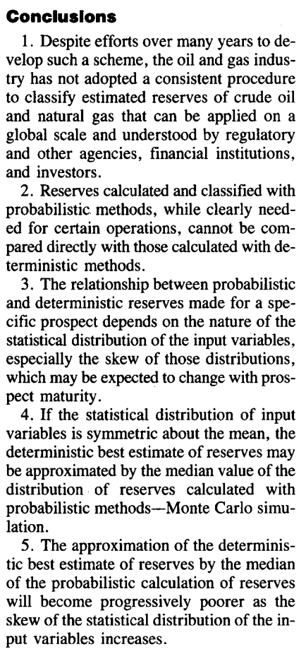

**Otis Parametric: A Process for Evaluating Exploration Prospects (searchable)**

Chevron developed a process to allow management to compare a wide variety of global exploration opportunities on a uniform and consistent basis. Over the next five years, the process evolved into an effective **method to plan exploration program on a basis of value incorporating prospect ranking, budget allocation, and technology management. Final product:** integration of geologic risk assessment, probabilistic distribution of prospect hydrocarbon volumes, engineering development planning, and prospect economics.

Overall probability of success is the multiplication of probability of geologic success and probability of commercial success. An important thing they do is compare the predicted success to the actual success (postdrill feedback) to see if the individual methods are working correctly to form the full integrated process. As an approach, the writer explains basic petroleum terms such as “play, prospect, basin framework.” Volumetric oil and gas distributions tend to be lognormal. Author explains how Monte Carlo simulation is used to estimate distribution of reserves using hundreds to thousands of iterations. The three-point method is an alternative to using MCS.

**SPE 71038: Applications of the Transient Hyperbolic Exponent (searchable)**

The transient hyperbolic exponent may be used to derive values for b for use in Aprs’ equations for a variety of drive mechanisms. Talks about different b factors for different reservoirs and b values according to pressure. Also b factors for different flow such finite, transient dual porosity reservoirs. Uses a coalbed methane well and 2 Antrim Shale wells as examples. They used reservoir simulators to do history matches and productions forecasts.

Coalbed methane reservoir example: the well exhibits true boundary dominated flow, production described by a material balance model relating pressure to fluid-in-place, and a deliverability model.

Conclusions:

1. The proposed definition for the transient hyperbolic exponent may be used to determine theoretical values for Arps’ hyperbolic exponent b for a variety of different drive mechanisms.

2. The transient hyperbolic exponent may be used to determine an appropriate value of b to use to parameterize the results of numerical simulation runs for use in economic evaluation.

3. For a coalbed methane reservoir, the b value will approach 1.5 for reservoir pressures much higher than the Langmuir pressure. As the reservoir pressure drops, the value of b will also drop, reaching a value of 1 when the reservoir pressure is equal to the Langmuir pressure, and approaching a value of 0.5 as the reservoir pressure falls below the Langmuir pressure. To our knowledge, this is the first drive mechanism shown to produce a b greater than 0.5 for a single-layer, homogeneous reservoir.

4. For a well in a finite, transient dual porosity reservoir, a flow regime characterized by steady-state flow in the fracture system and transient linear flow in the matrix may occur under certain circumstances. This flow period will exhibit a b value of 2.

5. Two Antrim Shale examples were shown where the hyperbolic exponent needed to match the results of a numerical simulation was 1.6, quite close to the theoretical value of 2 expected for transient linear flow in the matrix.

6. A coalbed methane example was shown where the hyperbolic exponent found to best fit a simulation forecast (0.6) was very close to that predicted (0.63 to 0.73).

**URTeC 2697318: Using a Systematic, Bayesian Approach to Unlock the True Value of Public Data; Midland Basin Study**

This paper presents a methodology to responsibly **exploit this vast public data source for strategic purposes using outlier identification, probabilistic forecasting tools, and Bayesian calibration to refine our analysis of multi-fractured horizontal well performance in the Midland Basin.** They have non operating companies working internally to understand operator well performance in the Midland Basin to gather higher quality data. The decline in oil prices made it harder for operators to find good-quality data.

A machine learning algorithm is used to perform probabilistic decline curve analysis in order to provide an objective forecast evaluation of horizontal well production. We demonstrate partial calibration of the data set to higher resolution daily data and Bayesian updating of every forecast in the analysis as additional data is incorporated each month. Repeated performance accuracy tracking and vintaging to show stability and predictability of the forecasts increases confidence in the methodology and data set.

Our work reveals that recently drilled wells (c. 2015–2016) are forecasted to recover significantly more reserves - nearly twice as much in some areas - as compared to early asset developments. Is this due to improved operator practices or higher-quality resources? The ability to answer this question is where we find the true value of public data.

The RAPID tool stochastically generates thousands of forecasts for thousands of wells in minimal amount of time using the “Markov-chain Monte Carlo” (MCMC) (Fulford et al. 2016) simulation technique and returns discretized fits from the posterior forecast distribution for the given production data. RAPID gives us the ability to provide an objective evaluation by reducing human bias through the MCMC simulation process.

Summary of their workflow:

* We generate discrete forecasts with unique decline parameters for every single well in the population instead of assigning a forecast derived from groups of wells
* We do not normalize production for lateral length or production down-time periods
* We avoid over-fitting of early-time production data by fitting the calibrated transient-hyperbolic model
* We create type curves from a process of feature extraction from single well forecasts; we do not create type curves by fitting to average production data from groups of wells

**Conclusions**

* The paper establishes a reliable and justified methodology to forecast rate-time behavior using public allocated production data and to establish predictive accuracy in production forecasts.
* The paper demonstrates the successful implementation of a Bayesian forecasting workflow using a machine learning forecasting algorithm to evaluate unconventional horizontal well performance in the Midland Basin.
* The paper highlights accuracy comparisons and calibration efforts using internal evaluations and higher- quality data to improve predictive accuracy and build confidence in project results.

**SPE 73828: Probabilistic Reserves! Here at last? (searchable)**

**Objective:** Paper focuses on how to dust off some of the mystery that about how to deal with reserves probabilistically and correct some common procedures that do not follow the laws of probability and thus produces the wrong answer. Example: it’s super illegal to add proved reserves form wells to get a proved field or reservoir reserves. Reserves estimates have always been probabilistic. The central limit theorem works over time in the oil and gas industry, since it insures that the distribution of remaining reserves is always log-normal.

**Approach:** talk about what’s wrong w adding reserves estimates, talks about how to combine them correctly, examine what a company can gain from reported assets when using probabilistic methods, then look at real reserves data. He continues to say how we should NEVER add proved reserves.

**Solution:** to add proved reserves, add the means of all the wells and add the variance of all the wells to get the field variance. With this, the distribution is still log-normal. Adding logarithms of variables is equivalent to multiplying the variables themselves. Thus, the same CLT that leads us to the normal distribution when adding or subtracting will take us to the log-normal when multi- plying and dividing.

**Conclusion:** Using spreadsheets allows for continuous updating without the use of MCS. Using probability distributions to estimate reserves might lead to legitimately increasing reported reserves.

**SPE 175527: Validating Analog Production Type Curves for Resource Plays (searchable)**

Intro: introduce the central limit theorem and talk about how it converges when you have more wells. (becomes more precise) You may start out with a lognormal distribution for EUR, but when you have more wells it goes to normal distribution.

The author recommends that you use a P10/P90 ratio to show whether estimation is going well. Then it shows you the methodology they use in the industry. First, create graph and it shows aggregation, so that when you go to the end of the graph, you’ll know what the P90 and P10 values are.

For step 2, go to 80% and look at percentage of the mean value and how much it deviates form the mean. You use that value and multiply it by P90 and P10. (explanation below graph)

Conclusions: Once your results converge, P10/P90 ratio decreases because they are closer together.

**SPE 134602: Using the SPE/WPC/AAPG/SPEE/SEG PRMS To Evaluate Unconventional Resources**

The PRMS method should provide consistent approach to estimating petroleum quantities regardless of whether a well is conventional or not, or of the in place characteristics etc. Unconventional resources may require additional density of sampling to define characteristics that evaluators are uncertain about, to increase quality of estimations.

This paper summarizes the special problems in the estimation and evaluation of shale gas. However, similar procedures can be used for other unconventional resources. Achieving a better understanding of the special problems in unconventional-resources evaluation will help us build on PRMS to develop a more consistent approach to classification and categorization, accounting for unique project risks and uncertainties.

Conclusions:

* Classification is based on the chance of commerciality of the project being applied.
* Categorization describes the relative uncertainty in the range of marketable volumes derived from applying the development project to an accumulation.
* Once exploratory drilling has demonstrated the presence of producible hydrocarbons in sufficient quantities to justify potential development, portions of the accumulation may be deemed discovered and thus reclassified from prospective to contingent resources. In the early stages, assessments are influenced by comparisons with similar reservoirs in more-mature development phases.